Town of Watertown
Construction Oversight Program
Jefferson County Stormwater Coalition
Updated: 2026

Abbreviations:
CGP- Construction General Permit
DEC- Department of Environmental Conservation
E&SC- Erosion and Sediment Control
ERP- Enforcement Response Plan
MS4- Municipal Separate Storm Sewer System; refer to maps in SWMP Plan to determine which areas in your municipality apply
SMP- Stormwater Management Practice
SWCD- Soil and Water Conservation District; also referred to as Soil and Water
SWMP- Stormwater Management Program
SWMP Plan- Stormwater Management Program Plan
SWPPP- Stormwater Pollution Prevention Plan

When this program applies:
This MS4 Construction Oversight Program addresses stormwater runoff from construction activities that a.) result in a total land disturbance of an acre or more or b.) disturb less than an acre, but are part of a larger common plan of development (e.g. a single sub-one acre lot in a housing development.)
- General rule of thumb: if construction lies within, or outlets to, an MS4 and a SWPPP is required this program applies.
  - Refer to maps in SWMP Plan to determine MS4 area
*Note: if the MS4 operator is listed as the owner/ operator on the Notice of Intent for coverage under the Construction General Permit (CGP), these additional oversights are not required. That said, these sites should still be ranked as high or low priority and appear on the MS4’s Construction Site Inventory. MS4 Operators must follow CGP guidance and MS4 good housekeeping procedures.
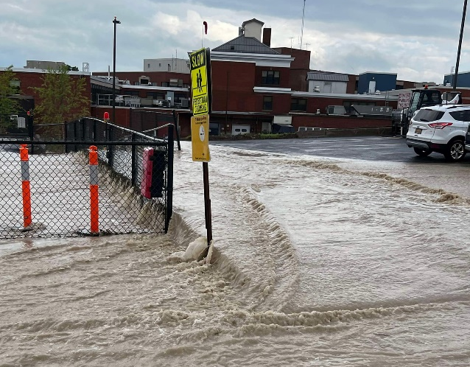
Goals of this program:
While the main objective of this program is to achieve compliance with the municipality’s MS4 Stormwater permit, it also sets the stage for effective post-construction runoff control in the community. Over the past few years, the North Country has begun to experience a greater number of high-intensity rainfall events with this trend expected to continue into the future.
This necessitates a greater emphasis on stormwater planning in community design and careful consideration of the stormwater impacts of new development. By designing sites with proper residence time the impacts of new development on stormwater runoff can be mitigated, protecting downstream neighbors from increased flooding. Considering the potential stormwater impacts of new development, and following best practices from the planning stage and beyond, allows communities to take an active role in minimizing the impacts of intense rainfall events.
Flooding at expanded Lowville Hospital site after intense rainstorm
SWPPPS
Construction activity that requires a SWPPP:
Refer to Appendix B of the Construction General Permit 0-20-001 for a list of construction activities. Table 1 contains activities that require the preparation of a SWPPP that only includes Erosion and Sediment Controls. Table 2 contains activities that require the preparation of a SWPPP that includes post-construction stormwater management practices (SMPs).
Procedures for submission of SWPPPs:
If a submitted project is listed in either Table 1 or Table 2 of Appendix B in the Construction General Permit, then a SWPPP shall be submitted for review and acceptance prior to the commencement of ground-disturbing activities.
SWPPP review Requirements:
MS4 operators must ensure individual(s) responsible for reviewing SWPPPs for acceptance have a valid DEC-endorsed 4-hour erosion and sediment control training certificate.
- Training attendance validates trainees for 3 years. Jefferson County Soil and Water Conservation District offers an annual training in March. Attendance is free for Coalition members.
Completion of this requirement must be documented in the SWMP.
**Individuals without this certificate can not review SWPPPs for acceptance unless they meet the definition of a qualified professional or qualified inspector.
Individuals responsible for reviewing SWPPPs must consider the size of the disturbance and/or common plan as well as for conformance with the Construction General Permit (CGP).
CGP considerations include:
- Erosion and sediment control conformance with the NYS E&SC 2016, or equivalent
- Individuals responsible for review of postconstruction SMPs are qualified professionals or under the supervision of a qualified professional
- Post-construction SMPs must be reviewed for conformance with the NYS Stormwater Management Design Manual 2015 or equivalent, including:
  - All post-construction SMPs meet the sizing criteria contained in the Construction General Permit and Stormwater Management Design Manual
    - Deviations from the performance criteria in the NYS Stormwater Management Design Manual must demonstrate that they are equivalent
  - The SWPPP must include an operation and maintenance plan that includes inspection and maintenance schedules as well as actions to ensure continuous and effective operation of each post-construction SMP.
    - The SWPPP must identify the entity responsible for the long-term operation and maintenance of each post-construction BMP practice.
SWPPP Acceptance:
To notify construction site owners/operators that their SWPPP has been accepted use the SWPPP Acceptance Form found in Appendix A.
SWPPP documentation required for inclusion in the SWMP Plan:
- Annually, the SWMP Plan must be updated with the names, titles, and contact information of the individuals who have received 4-hour erosion and sediment control training.
- Add accepted SWPPPs to the table in the SWMP Plan and report to Jefferson County SWCD within 30 days
  - Consult with Jefferson County Soil and Water Conservation District to prioritize sites as high or low priority based on criteria outlined in MS4 general permit 0-24-001 section VI.D.5.a.
- Document SWPPP review, including the information found in Part III.B. of the Construction General Permit

Example SWPPP review process based on guidance from the Center for Watershed Protection’s Guide for Building an Effective Post-Construction Program:
Municipality
Applicant
1. Materials and forms made available to regulated community
3. Submit concept plan, application, & applicable fees
4. Submittal accepted as complete: Review Initiated
Iterative

6. Resubmit to address comments
8. Submit Final Design/Plan, stormwater computations, application, & applicable fees
9. Submittal accepted as complete: Review initiated
Iterative

11. Resubmit to address comments
12. Coordinate with other internal or local reviews
14. Maintenance Agreement completed & recorded
16. Applicable information documented in SWMP Plan
10. Review & comment on Final Design/Plan
13. Verify all state/ federal permits for work in streams/ wetlands, and floodplains as applicable
15. Final Design/Plan Approved
7. Concept Plan Approval

5. Review and comment on concept plan

2. Pre-submittal meeting
(recommended; not required)
Pre-Construction Oversight Requirements:
Prior to the commencement of construction activities, the MS4 Operator must ensure a pre-construction meeting is conducted.
- The date and content of this meeting must be documented in the SWMP Plan
- The owner/operator listed on the CGP NOI, the MS4 Operator, contractor(s) responsible for the SWPPP for the construction activity, and the qualified inspector (if required for the construction activity by Part I.V.C. of the CGP) must attend the meeting in order to:
  - Confirm the approved project has received, or will receive, coverage under the CGP or an individual SPDES permit
  - Verify contractors and subcontractors have identified at least one individual that has a current DEC-endorsed four-hour erosion and sediment control certificate as required by the CGP and the MS4 General Permit
  - Review this construction oversight program and expectations for compliance
- If post-construction SMPs are included in the project plan (bioswales, retention ponds, permeable pavement, etc) identify pivotal points in construction for inspections to confirm proper installation and identify the responsible party for post-construction SMP inspections and maintenance
  - Document when these inspections are required and who is responsible
    - MS4s can charge for this service as outlined in adopted stormwater laws (Chapters 88 and 88a of the Code of the Town of Watertown).
Construction Site Inspections:
Individuals responsible for construction site inspections must have a current DEC-endorsed four-hour erosion and sediment control certificate before conducting construction site inspections. MS4 Operators must document the completion of this training in the SWMP Plan.
**Individuals without this certificate can not review SWPPPs for acceptance unless they meet the definition of a qualified professional or qualified inspector.
Additionally, inspection staff must be trained on the Construction Oversite Procedures (this document) and applicable Enforcement Response Procedures (from your municipality’s ERP). Training of the MS4 Operator’s construction oversight procedures must be given prior to conducting construction oversight, after any policy change, or once every five years. This training must be reported to Jefferson County SWCD to be recorded in the SWMP.
All sites with construction activity identified in an MS4s construction site inventory must be annually inspected during active construction (after the pre-construction meeting), or sooner if deficiencies are noted that require attention.
- Follow-up inspections must confirm corrective actions are completed within timeframes established by the Construction General Permit (CGP) and the MS4 Operator’s Enforcement Response Plan (ERP)
All inspections must be documented using the Construction Site Inspection Report Form, Appendix B. Completed forms must be included in the SWMP Plan and submitted to Jefferson County Soil and Water Conservation District.
Additional Inspections:
If the site has SMPs for post-construction stormwater management, inspections should occur at pivotal points throughout the installation process by an engineer. These “pivotal points” will vary by practice but should be identified in the SWPPP review process. By ensuring SMPs are built and installed correctly the municipality will ensure optimal storage and treatment of stormwater for the life of the practice, reducing potential flooding and water quality concerns.
Construction Site Close-out:
For a project to be considered complete, the MS4 operator must ensure a.) a final construction site inspection is conducted and b.) the Notice of Termination is signed by the MS4 Operator as required by the CGP
- The final construction site inspection must either be documented using the Construction Site Inspection Report Form, Appendix B, or the MS4 operator can accept the construction site owner/operator’s qualified inspector’s final inspection certification required by the CGP
Report completed close-outs to Jefferson County Soil and Water Conservation District within 30-days and update “Current Project Status” to “Complete” on the construction site inventory in your municipality’s SWMP Plan.

Appendix A. SWPPP Acceptance Form:
(see next page)

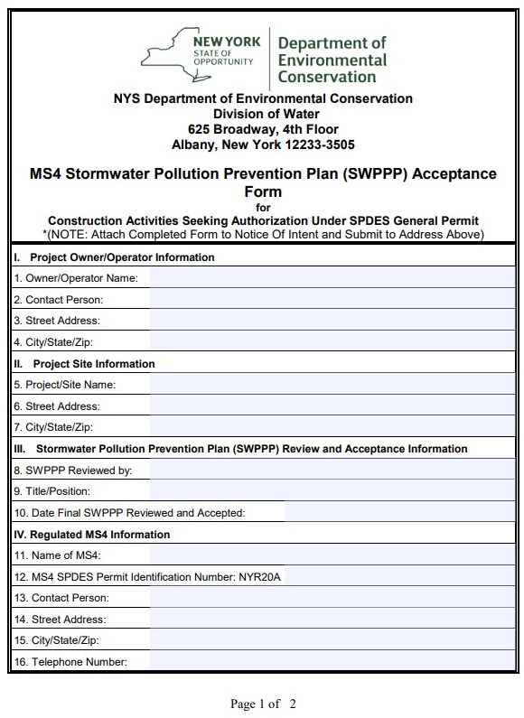
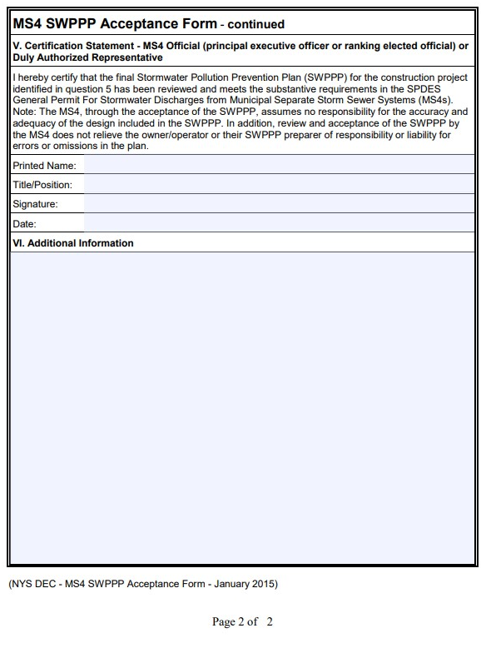
Appendix B. Construction Site Inspection Report Form:
(see next page)

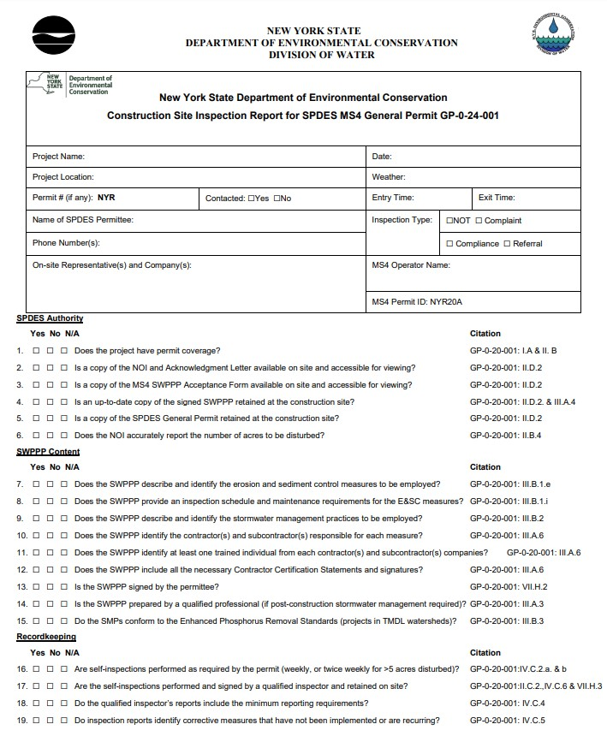

Page 1 of 3
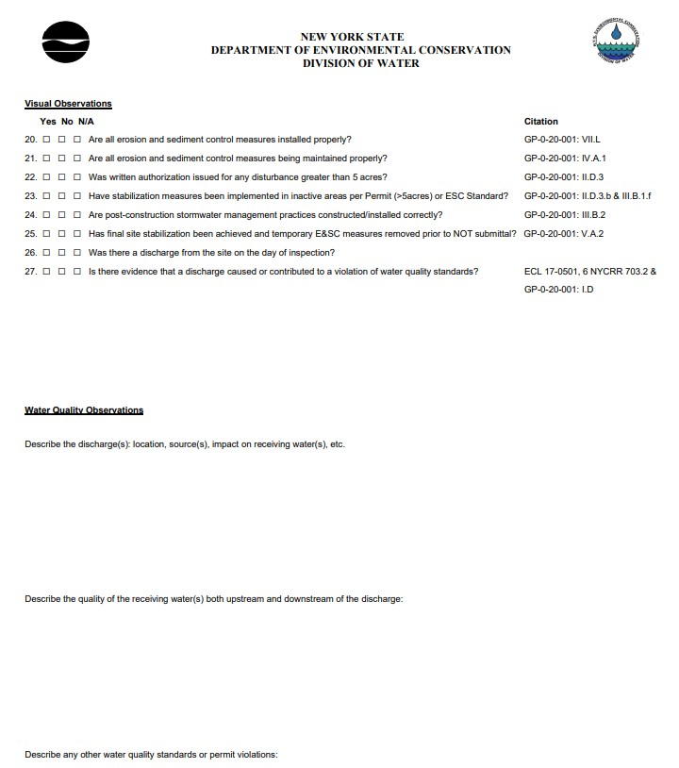

Page 2 of 3
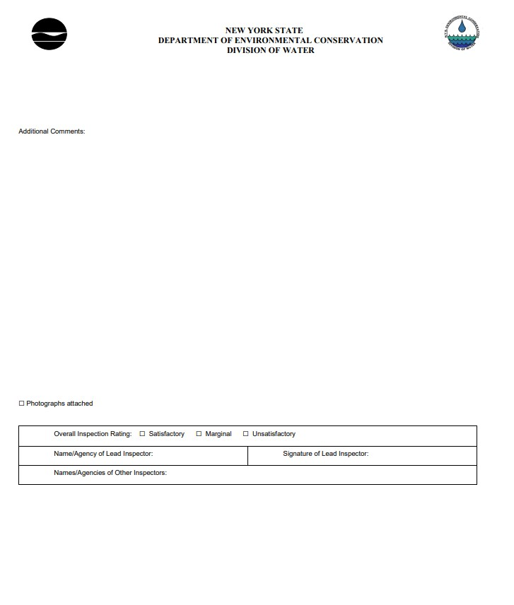

Page 3 of 3

Residence time is an engineering term, which in this context would describe the amount of time it takes a drop of water falling on the site to leave the site. Post-construction SMPs should be designed to hold this raindrop for at least the same amount of time it would have taken to leave the site before development.
Qualified Professional – a licensed Professional Engineer, Registered Landscape Architect, or other DEC endorsed individual(s).
Qualified Inspector –a licensed Professional Engineer, Certified Professional in Erosion and Sediment Control (CPESC), Registered Landscape Architect, or other DEC endorsed individual(s). It can also mean someone working under the direct supervision of, and at the same company as, the licensed Professional Engineer or Registered Landscape Architect, provided that person is working under the direct supervision of the licensed Professional Engineer or Registered Landscape Architect and has a current DEC-endorsed erosion and sediment control certification.
Ensuring SMPs in private developments are installed as designed before signing off via the construction site close-out process is a municipality’s best chance to ensure the SMP will function as designed, as it is difficult to require modification after that point. A number of small things can go wrong throughout the installation process that could severely impact the amount of water an SMP will hold or treat. Some examples include site grading, stone/gravel size used, incorrect installation or lack of geotextile materials, compaction, etc.

